Laravel 8 Localization Use Multiple language in website laravel

url: <https://www.youtube.com/watch?v=Q2EzNPA6M2U>

step: 1

first create route and controller:

Route::get('/language/{language}', 'LaguageController@languageSwitch')->name('language');

class LaguageController extends Controller

{

    public function languageSwitch($language){

        session(['APP_LOCALE' => $language]);

        return redirect()->back();

    }

}

Step 2: create Middleware name of locale and middleware must be registered in kernel

 protected $middlewareGroups = [

        'web' => [

            \Illuminate\Routing\Middleware\SubstituteBindings::class,

            \App\Http\Middleware\locale::class,

        ],

* Php artisan make:middleware locale
* public function handle($request, Closure $next)
* {
* $availableLocale = array('en','bn');
* if(Session::has('APP_LOCALE')){
* $locale = in_array(session('APP_LOCALE'),$availableLocale) ? session('APP_LOCALE'): config('app.locale');
* app()->setLocale($locale);
* }
* return $next($request);
* }

Step 3:

Language file create in resource> lang > en and bn directory name of home.php

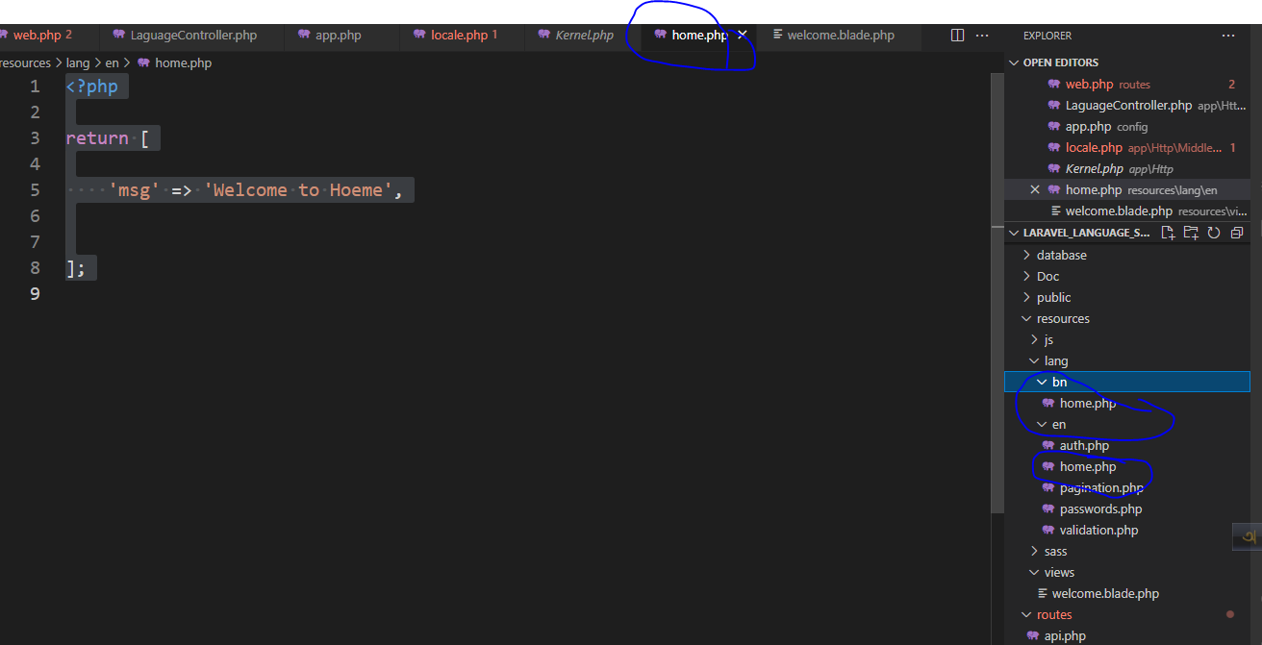

* Resource > lang > en> home.php
* <?php
* return [
* 'msg' => 'Welcome to Hoeme',
* ];
* Resource > lang > bn> home.php
* <?php
* return [
* 'msg' => 'হোমে স্বাগতম',
* ];

Last step:

All show in blade file:

<ul>

                    <li>

                        <a href="{{ route('language',['language'=>'en']) }}">English</a>

                    </li>

                    <li>

                        <a href="{{ route('language',['language'=>'bn']) }}">Bangla</a>

                    </li>

                </ul>

                <h1>{{ __('home.msg') }}</h1>